**A PROJECT REPORT**

**on**

**“Number Plate Recognition System”**

**Submitted to**

**KIIT Deemed to be University**

**In Partial Fulfilment of the Requirement for the Award of**

**BACHELOR’S DEGREE IN**

**INFORMATION TECHNOLOGY**

**BY**

**SANKALP PATRA** 2105402

**RAJ ARYAN** 2105986

**ABHIJEET KUMAR** 22057001

**MALOTH RAJSHEKHAR** 2105381

**MAYANK** 2105674

**UNDER THE GUIDANCE OF**

**Sourav Kumar Giri**



**SCHOOL OF COMPUTER ENGINEERING**

**KALINGA INSTITUTE OF INDUSTRIAL TECHNOLOGY**

**BHUBANESWAR, ODISHA - 751024**

**April 2024**

KIIT Deemed to be University

School of Computer Engineering

Bhubaneswar, ODISHA 751024



CERTIFICATE

This is to certify that the project entitled

“Number Plate Recognition System”

submitted by

RAJ ARYAN 2105986

SANKALP PATRA 2105402

ABHIJEET KUMAR 22057001

MALOTH RAJSHEKHAR 2105381

MAYANK2105674

is a record of bonafide work carried out by them, in the partial fulfilment of the requirement for the award of Degree of Bachelor of Engineering (Computer Science & Engineering) at KIIT Deemed to be university, Bhubaneswar. This work is done during year 2023-2024, under our guidance.

Date: 04/04/2024

Sourav Kr Giri

Project Guide

**Acknowledgements**

We are profoundly grateful to **Sourav Kr Giri** of **Affiliation** for his expert guidance and continuous encouragement throughout to see that this project rights its target since its commencement to its completion.

RAJ ARYAN

SANKALP PATRA

ABHIJEET KUMAR

MALOTH RAJSHEKHAR

MAYANK

**ABSTRACT**

The Number Plate Recognition System presented in this project leverages computer vision techniques and optical character recognition (OCR) to detect and recognize number plates in real-time video streams. Implemented using Python and OpenCV, the system processes each frame of the video, identifies number plate regions using a pre-trained Haar cascade classifier, and extracts the alphanumeric characters using Tesseract OCR. The recognized plate numbers are then matched against a database of registered vehicles stored in MongoDB. Upon successful recognition, the system retrieves and displays associated vehicle information, such as owner name, make, model, and color, on the video frame. Additionally, recognized plates are logged into a historical database for further analysis and tracking.

The system also includes a web interface built with Flask, enabling functionalities like adding new vehicles to the database and viewing recognized plate records. Moreover, to ensure secure access, the system incorporates user authentication, requiring admin credentials for certain operations. Overall, the Number Plate Recognition System offers a robust solution for automatic vehicle identification, with potential applications in traffic management, law enforcement, and parking systems.

**Keywords:**

1. Number Plate Recognition System
2. Computer Vision
3. Optical Character Recognition (OCR)
4. Real-time Video Processing
5. OpenCV
6. Tesseract OCR
7. MongoDB
8. Vehicle Database
9. Vehicle Identification
10. Flask Web Interface

Contents

|  |  |  |  |  |
| --- | --- | --- | --- | --- |
| 1 | Introduction | | | 1 |
| 2 | Literature Review | | | 3 |
| 3 | Problem Statement / Requirement Specifications | | | 6 |
|  | 3.1 | Project Planning | | 6 |
|  | 3.2 | Project Analysis (SRS) | | 9 |
|  | 3.3 | System Design | | 11 |
|  |  | 3.3.1 | Design Constraints | 11 |
|  |  | 3.3.2 | System Architecture | 12 |
|  |  | 3.3.3 | Use Case Diagram | 12 |
| 4 | Implementation | | | 13 |
|  | 4.1 | Methodology | | 13 |
|  | 4.2 | Testing or Verification Plan | | 15 |
|  | 4.3 | Result Analysis / Screenshots | | 16 |
| 5 | Standard Adopted | | | 18 |
|  | 5.1 | Design Standards | | 18 |
|  | 5.2 | Coding Standards | | 19 |
|  | 5.3 | Testing Standards | | 19 |
| 6 | Conclusion and Future Scope | | | 20 |
|  | 6.1 | Conclusion | | 20 |
|  | 6.2 | Future Scope | | 21 |
| References | | | | 22 |
| Plagiarism Report | | | | 24 |

List of Figures

|  |  |  |
| --- | --- | --- |
| 1.1 | Number plate of vehicle is being scanned | 1 |
| 1.2 | Project schedule (Gantt chart) | 2 |
| 1.3 | System Architecture | 12 |
| 1.4 | Use case diagram | 12 |
| 1.5 | Scanning Number Plate of a Vehicle | 16 |
| 1.6 | Previous 24 hours Data | 16 |
| 1.7 | Recognized Plates | 17 |
| 1.8 | Add Vehicle Details | 17 |

*Number Plate Recognition System*

Chapter 1

Introduction

In recent years, the integration of computer vision technologies with everyday applications has led to significant advancements in various fields, ranging from surveillance and security to transportation and automation. One such application is the development of a Number Plate Recognition System, which employs a combination of image processing techniques and optical character recognition (OCR) to automatically identify and recognize number plates in real-time video streams. This system holds immense potential for enhancing traffic management, law enforcement, and parking systems by providing efficient and accurate vehicle identification capabilities.

In recent years, the integration of computer vision technologies with everyday applications has led to significant advancements in various fields, ranging from surveillance and security to transportation and automation. One such application is the development of a Number Plate Recognition System, which employs a combination of image processing techniques and optical character recognition (OCR) to automatically identify and recognize number plates in real-time video streams. This system holds immense potential for enhancing traffic management, law enforcement, and parking systems by providing efficient and accurate vehicle identification capabilities.

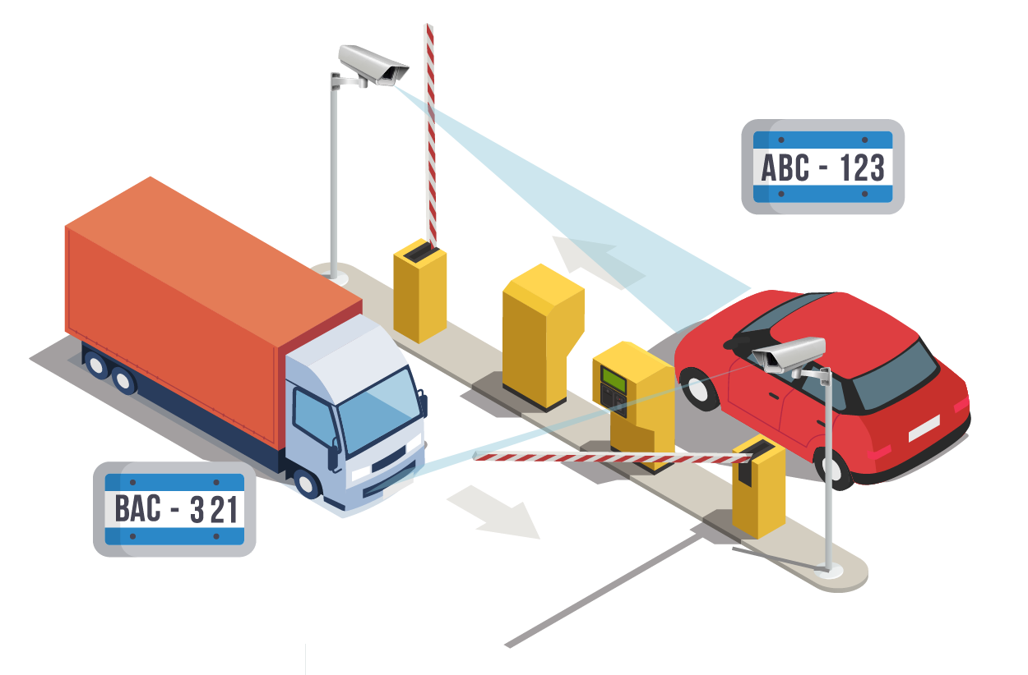

Fig 1.1 Number plate is being recognized

*School of Computer Engineering, KIIT, BBSR* 1

*Number Plate Recognition System*

Key components of the Number Plate Recognition System include a Haar cascade classifier for number plate detection, Tesseract OCR for character recognition, and MongoDB for storing and managing vehicle information. The system architecture is designed to facilitate real-time processing of video streams, ensuring prompt identification of vehicles as they pass through the monitored area. Additionally, a user-friendly web interface built with Flask framework allows for functionalities such as adding new vehicles to the database and viewing recognized plate records.

This project aims to address several challenges associated with Number plate recognition, including variations in plate appearance due to factors such as lighting conditions, viewing angle, and occlusions. Advanced image processing techniques are employed to enhance the robustness and accuracy of plate detection and character recognition, thereby improving the overall performance of the system. Furthermore, the integration of user authentication mechanisms ensures secure access to system functionalities, preventing unauthorized users from tampering with the database or system settings.

*School of Computer Engineering, KIIT, BBSR* 2

*Number Plate Recognition System*

Chapter 2

Literature Review

Number plate recognition (NPR), also referred to as automatic number plate recognition (ANPR), has garnered significant attention in both academic research and practical applications, owing to its diverse range of uses in security, transportation, and law enforcement. NPR systems employ computer vision techniques and optical character recognition (OCR) to automatically detect, localize, and recognize number plates from images or video streams. The literature on NPR encompasses a broad array of topics, including fundamental concepts, methodologies, algorithms, challenges, and applications.

1. **Image Acquisition and Processing.**

* NPR systems commonly commence by obtaining images or video feeds featuring vehicles and their number plates. These visuals can be obtained through specialized cameras, CCTV systems, or surveillance setups.
* To refine the quality and clarity of these captured images, preprocessing methods like noise reduction, image enhancement, and normalization are frequently applied. These techniques aim to enhance the visual data, thus aiding in the subsequent processing phases.

1. **Number Plate Localization.**

* The process of number plate localization entails identifying and isolating number plate regions within the acquired images. Various methods such as edge detection, morphological operations, and template matching are employed to achieve this goal effectively.
* However, challenges in number plate localization arise due to factors like fluctuations in illumination, perspective distortion, occlusions, and the diverse array of plate designs observed across different regions and types of vehicles. These complexities necessitate robust algorithms and techniques capable of accurately identifying number plate regions under diverse environmental conditions.

*School of Computer Engineering, KIIT, BBSR* 3

*Number Plate Recognition System*

1. **Character Segmentation.**

* After successfully localizing the number plate region, the subsequent step involves segmenting individual characters or symbols from the plate. Commonly utilized techniques for character segmentation include connected component analysis, contour analysis, and morphological operations.
* However, challenges in character segmentation emerge from issues like overlapping characters, inconsistencies in fonts and sizes, as well as the presence of noise and artifacts within the images. These complexities necessitate the development of robust segmentation algorithms capable of accurately isolating individual characters despite these challenges.

1. **Optical Character Recognition (OCR).**

* Optical Character Recognition (OCR) algorithms play a pivotal role in recognizing and interpreting the segmented characters, converting them into textual or alphanumeric representations. Traditional OCR methods typically involve techniques such as feature extraction, template matching, and classification to achieve accurate character recognition.
* However, recent advancements in deep learning, particularly convolutional neural networks (CNNs), have revolutionized OCR technology. These advancements have resulted in substantial improvements in OCR accuracy and robustness by enabling end-to-end training of models on extensive datasets. CNNs excel in learning intricate patterns and features directly from raw data, making them highly effective for character recognition tasks within Number plate recognition systems.

1. **Applications and Practical Implementations.**

* NPR technology finds diverse applications across multiple domains, including security surveillance, traffic management, toll collection, parking enforcement, and law enforcement. Its versatility allows for its integration into various systems and processes aimed at enhancing safety, efficiency, and security in these areas.
* Practical implementations of NPR systems span a wide spectrum, ranging from standalone devices tailored for parking management to comprehensive solutions integrated into smart cities and transportation infrastructure. These implementations leverage the capabilities of NPR technology to streamline operations, improve traffic flow, enhance security measures, and optimize resource allocation in urban environments.

*School of Computer Engineering, KIIT, BBSR* 4

*Number Plate Recognition System*

1. **Challenges and Future Directions:**

* Although significant advancements have been achieved in NPR technology, numerous challenges remain, including variations in environmental conditions, vehicle speeds, number plate designs, and regulatory constraints. These challenges pose hurdles to the accurate and reliable operation of NPR systems, requiring further research and innovation to overcome.
* Future research directions in NPR encompass the development of robust algorithms capable of handling challenging scenarios encountered in real-world applications. Additionally, there is a growing interest in integrating NPR with other sensor modalities such as lidar and radar to enhance detection capabilities and improve overall system performance. Moreover, addressing ethical and privacy concerns surrounding the deployment of NPR systems is essential, ensuring responsible and transparent use of this technology while safeguarding individual rights and liberties.

1. **Database Management:**

* The literature on Number plate recognition (NPR) offers a thorough exploration of the fundamental concepts, methodologies, challenges, and applications inherent to this technology. It underscores the critical role of NPR in diverse domains such as security, transportation, and law enforcement, highlighting its potential to enhance safety, efficiency, and security in these areas. Continued research and innovation in NPR are imperative for advancing its capabilities and meeting the evolving needs of society. By addressing challenges and exploring new avenues, NPR can further solidify its position as a vital tool for improving surveillance, traffic management, and law enforcement practices.

*School of Computer Engineering, KIIT, BBSR* 5

*Number Plate Recognition System*

Chapter 3

Problem Statement / Requirement

Specification

The project aims to address challenges in Number plate recognition (NPR), including variations in environmental conditions and diverse plate designs. Leveraging advancements in computer vision and machine learning, the objective is to develop a robust and efficient NPR system. Integration with other sensor modalities, like lidar and radar, presents a complex challenge requiring innovative solutions. Ethical and privacy concerns surrounding NPR deployment underscore the need for responsible technology development. By meticulously researching and experimenting, the project seeks to enhance NPR accuracy and reliability. The ultimate goal is to contribute to the evolution of NPR technology and its seamless integration into real-world applications.

3.1 Project Planning

3.1.1 Effort Estimation

This project spanned approximately 2.5 months, with the effort distributed across various stages. Data collection, pre-processing, and model development consumed the majority of the time, requiring careful attention to data quality and feature engineering. Literature review and report writing were completed within a reasonable timeframe, ensuring a solid foundation for the project and clear communication of the findings. The estimated effort aligns well with the actual project duration, demonstrating efficient time management throughout the development process.

*School of Computer Engineering, KIIT, BBSR* 6

*Number Plate Recognition System*

3.1.2 Project Schedule (Gantt Chart)



Fig 1.2

3.1.3 Staffing

In the Number Plate Recognition System project, a division of labor strategy was employed, allocating tasks to team members based on their expertise:

* Members were assigned the task of completing both the backend and frontend components for the web page. This allocation ensured that team members were responsible for developing and integrating all aspects of the web application, from server-side functionalities to user interface design, to create a cohesive and functional system.
* Members were tasked with collecting various datasets and collaborating on the development of the camera system. This distributed responsibility allowed for comprehensive data acquisition and facilitated the enhancement of the camera system's capabilities through collaborative efforts and diverse expertise.
* In addition to model specialization and algorithm expertise, certain team members were dedicated to preparing the project report. This division of labor ensured that there was focused attention on documenting the project's progress, methodologies, and outcomes, facilitating comprehensive reporting and dissemination of project findings.

3.1.4 Schedule and Responsibilities

The provided schedule (February - April) suggests a breakdown of activities across weeks:

February (Weeks 1-4): Introduction, Sub-Section development (likely literature review sections), ER/Use Case diagrams (potentially for deployment) likely involved all team members.

*School of Computer Engineering, KIIT, BBSR* 7

*Number Plate Recognition System*

March (Weeks 1-3): Model Building phases indicate dedicated work by respective team members on their assigned models, Methodology, Analysis.

March (Week 4) - April: Design/Coding Standards, Conclusion, and Model Deployment likely involved collaboration across the team.

3.1.5 Risk Management

**Identified Risk:**

1. Image Quality Concerns: The input images of vehicle number plates may vary in quality, potentially leading to challenges in accurate detection and recognition.
2. Algorithm Performance Constraints: The selected image processing and OCR algorithms might encounter difficulties in achieving high accuracy rates for all types of number plates.
3. Technical Constraints: Potential issues with code implementation, software compatibility, or hardware capabilities could impede the smooth functioning of the Number Plate Recognition System.
4. Project Timeline Constraints: Unforeseen delays during development or testing phases could impact the project's overall schedule and delivery timeline.
5. Expertise Gaps: Team members may encounter challenges due to limited familiarity or expertise with certain image processing techniques or OCR algorithms, potentially affecting the system's performance.

**Mitigation Strategies:**

**Image Quality Concerns:**

1. Preprocessing Techniques: Apply image preprocessing methods such as noise reduction, contrast enhancement, and normalization to improve the quality and clarity of input images.
2. Quality Assurance Checks: Implement quality assurance measures to identify and discard low-quality images before processing.
3. Calibration Procedures: Regularly calibrate the imaging hardware to maintain consistent image quality across different capture environments.
4. Algorithm Robustness: Develop algorithms resilient to variations in image quality, such as adaptive thresholding and feature normalization techniques.

*School of Computer Engineering, KIIT, BBSR* 8

*Number Plate Recognition System*

**Model Performance:**

1. Parameter Optimization: Employ techniques such as grid search or random search to optimize the parameters of the detection algorithms, enhancing their accuracy and robustness in recognizing number plates.
2. Ensemble Learning: Explore ensemble methods like bagging or boosting to combine multiple detection models, potentially improving overall performance and generalization ability.
3. Transfer Learning: Investigate the applicability of transfer learning by leveraging pre-trained models or features from related tasks to enhance the accuracy of the Number Plate Recognition System.

**Time Management:**

1. Agile Approach: Embrace an agile project management methodology to iteratively develop and test the system, allowing for flexibility in responding to changing requirements and mitigating potential delays.
2. Task Prioritization: Prioritize tasks based on their importance and dependencies, focusing on critical components such as image preprocessing and OCR integration to ensure timely completion.
3. Continuous Monitoring: Regularly monitor project progress and adjust plans as needed to address any unexpected challenges or delays, ensuring that the project stays on track for timely delivery.

3.2 Project Analysis

3.2.1 Purpose

The purpose of this document is to delineate the software specifications for constructing a Number Plate Recognition System. The system will harness machine learning models to identify and recognize vehicle number plates based on input images.

3.2.2 Scope

The system will be developed using Python and OpenCV for image processing, integrated with a web interface created using Flask. It will facilitate users to upload images containing vehicle number plates for recognition. Subsequently, the SVM model will analyze the images to extract and display the recognized number plate information.

*School of Computer Engineering, KIIT, BBSR* 9

*Number Plate Recognition System*

3.2.3 Functional Requirement

**User Interface:**

1. Number Plate Recognition: Users will scan images containing vehicle number plates through the web interface.
2. Recognition Button: The system shall feature a button labelled "Recognize" to initiate the number plate recognition process.

**Recognition Process:**

1. SVM Model: For number plate recognition, the system shall employ the SVM model to analyse the uploaded images and identify the location of the number plate within the image.
2. LR Model: In addition to SVM, the system shall utilize the LR model to extract alphanumeric characters from the identified number plate region, converting them into textual representations.

3.2.4 Non-Functional Requirements

**Performance**

1. The system shall deliver swift recognition results.
2. Both SVM and LR models shall be optimized for efficient processing and accuracy in recognizing number plates.

**Usability**

The web interface shall be user-friendly, featuring clear instructions and intuitive controls for uploading images and initiating recognition.

**Error Handling**

The system shall provide informative error messages in case of invalid image uploads or processing failures.

**Reliability**

The system shall handle unexpected errors gracefully, ensuring minimal disruption to the recognition process and user experience.

**Conclusion**

This project analysis outlines the software requirements for constructing a Number Plate Recognition System using SVM and LR models integrated with a Flask web interface. By adhering to these specifications, the system aims to provide efficient and accurate recognition of vehicle number plates in a user-friendly manner.

*School of Computer Engineering, KIIT, BBSR 10*

*Number Plate Recognition System*

3.3 System Design

3.3.1 Design Constraints

**Hardware**

This section delineates the working environment and constraints pertinent to the Number Plate Recognition System. Software requisites encompass Python, OpenCV, and Flask for executing image processing tasks and developing the web application interface. Concurrently, hardware prerequisites may encompass a camera for image acquisition and a computing device capable of running the system efficiently. It's imperative to note that the system is designed to operate within a virtual environment on an Ubuntu-based system. Adequate RAM is essential to ensure smooth execution of the system's functionalities.

System: AMD Ryzen 7 5700U 1.8GHz

SSD: 512 GB

Display: 14”

Ram: 16 GB

OS: Ubuntu / Windows 10,11

IDE: VS Code

**Software**

Machine Learning Libraries: The Number Plate Recognition System likely utilizes libraries such as OpenCV and pytesseract in Python for image processing and Optical Character Recognition (OCR).

Data Analysis Tools: The system may employ OpenCV and NumPy for data exploration and manipulation tasks. These tools allow for the processing of image data, including grayscale conversion, edge detection, and contour tracing, which are crucial for preprocessing and extracting number plate regions from input images.

Visualization Tools: Tools like OpenCV & matplotlib have been used to visualize the results of the number plate detection process. Matplotlib can generate visualizations such as bounding boxes around detected number plates or display histograms of image features, aiding in the analysis and evaluation of the system's performance.

Report Writing Software: For documenting the project, developers likely used text editors like VS Code for writing code and generating reports. Additionally, Markdown or HTML could have been employed for formatting text.

*School of Computer Engineering, KIIT, BBSR 11*

*Number Plate Recognition System*

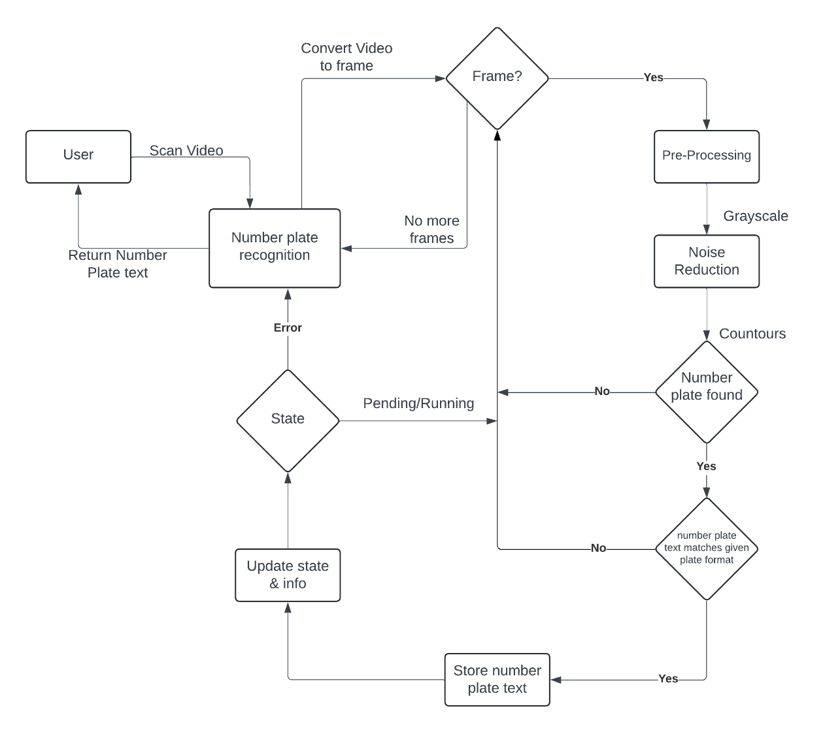3.3.2 System Architecture

Fig 1.3

3.3.3 Use Case Diagram

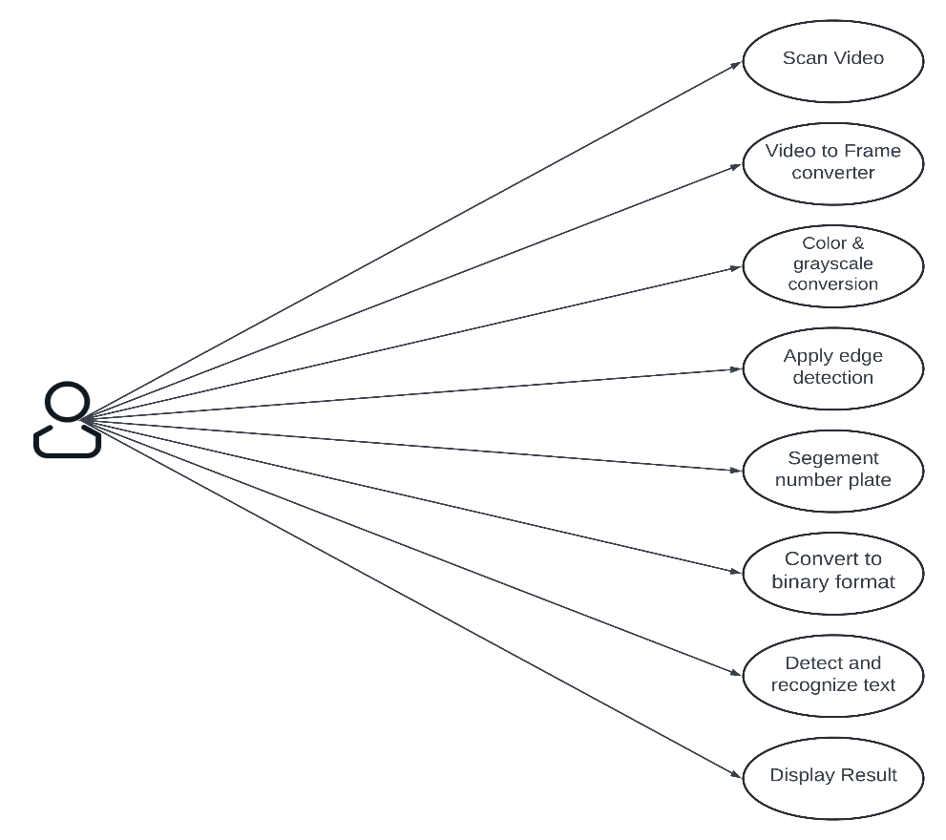

Fig 1.4

*School of Computer Engineering, KIIT, BBSR* 12

*Number Plate Recognition System*

Chapter 4

Implementation

4.1 Methodology Proposal:

The proposed methodology integrates principles from Image Processing and Machine Learning with specific algorithms and techniques tailored for our number plate detection system, utilizing data collected from various sources. Below is an outline of the steps adopted for completing the project work.

4.1.1 Data Collection

Collect large volumes of image data containing Indian vehicle number plates from various sources.

* Identify and select datasets containing images with Indian vehicle number plates, ensuring they cover a diverse range of scenarios and conditions.
* Ensure the datasets include relevant information such as different types of vehicles, varying lighting conditions, and angles.

4.1.2 Preprocessing

* Data Integrity: Ensured the accuracy of image data by verifying the dimensions and quality of the images. Performed statistical analysis to identify and address any irregularities or anomalies in the dataset.
* Distribution Analysis: Conducted an analysis of the distribution of images containing number plates, categorizing them based on the presence (1) or absence (0) of a valid number plate.
* Data Aggregation: Aggregated image data as needed to consolidate multiple images into a unified representation, streamlining subsequent processing stages.
* Standardization: Standardized image data to adhere to established norms and specifications, ensuring uniformity and compatibility with subsequent processing stages.

*School of Computer Engineering, KIIT, BBSR* 13

*Number Plate Recognition System*

4.1.3 Features Extraction

* Number Plate Localization: Implemented techniques like contour tracing and filtering to accurately identify and extract the region of interest containing the number plate from the input image.
* Character Segmentation: Employed methods to segment individual characters from the localized number plate region, ensuring precise recognition of alphanumeric characters.
* Feature Encoding: Converted segmented characters into numerical representations or feature vectors, facilitating further processing by machine learning algorithms.
* Pattern Recognition: Utilized machine learning algorithms to recognize and interpret the encoded features, enabling the system to decipher and extract meaningful information from the number plate.
* Enhanced Accuracy: By integrating robust feature extraction techniques, the system achieved enhanced accuracy in detecting and recognizing number plates, thereby improving overall performance in vehicle identification tasks.

4.1.4 Model Selection

Haar Cascade Classifiers: Haar Cascade classifiers are popular for object detection tasks, including face detection and, in this case, number plate detection. These classifiers are efficient and can provide real-time performance, making them suitable for applications where computational resources are limited.

4.1.5 Model Training

* Data Collection and Annotation: Gather positive and negative images, annotate positive images with bounding boxes indicating number plate locations.
* Feature Extraction: Extract Haar-like features from annotated images to represent patterns of intensity variation.
* Training Data Preparation: Format the positive and negative samples along with their features for input into the OpenCV training cascade.
* Cascade Classifier Training: Train the cascade classifier using the AdaBoost algorithm, adjusting parameters to optimize performance.
* Testing and Integration: Evaluate the trained classifier's performance on test data, fine-tune parameters as needed, and integrate the classifier into the number plate detection system for real-time use.

*School of Computer Engineering, KIIT, BBSR* 14

*Number Plate Recognition System*

4.1.6 Model Evaluation

Model evaluation for the number plate detection system involves assessing accuracy, precision, recall, and F1 score to gauge detection performance. Additionally, analyzing the false positive rate and computational efficiency ensures robustness and practical applicability. Cross-validation validates the model's generalization across varied datasets.

4.2 Testing or Verification Plan

|  |  |  |  |  |
| --- | --- | --- | --- | --- |
| Test ID | Test Case Title | Test Condition | System Behaviour | Expected Result |
| T01 | Data Preprocessing Test | Raw textual data is input for preprocessing | Data preprocessing successfully cleanses and tokenizes the text, handling noise and normalization effectively | Pre-processed data is ready for feature extraction and model training |
| T02 | Model Training Test | Pre-processed data is input for model training | Models are trained using appropriate algorithms with optimized hyperparameters | Trained models exhibit satisfactory performance metrics on the testing data |
| T03 | Interpretation and Visualization Test | Trained models are interpreted and visualized | Key insights are extracted from the models, and visualizations effectively communicate the results | Stakeholders gain valuable insights into number plate detection and decision-making |

Alpha Testing:

* Conducted internally by the development team before releasing the software to external users.
* Focuses on identifying and fixing issues within the software before it reaches a wider audience.

*School of Computer Engineering, KIIT, BBSR* 15

*Number Plate Recognition System*

* Test cases include:

1. Data Preprocessing Test: Ensuring that raw textual data is effectively cleaned and tokenized.
2. Model Training Test: Verifying that models are trained accurately and perform satisfactorily on test datasets.
3. Interpretation and Visualization Test: Validating that insights from trained models are correctly interpreted and visualized.

4.3 Screenshot or Result Analysis

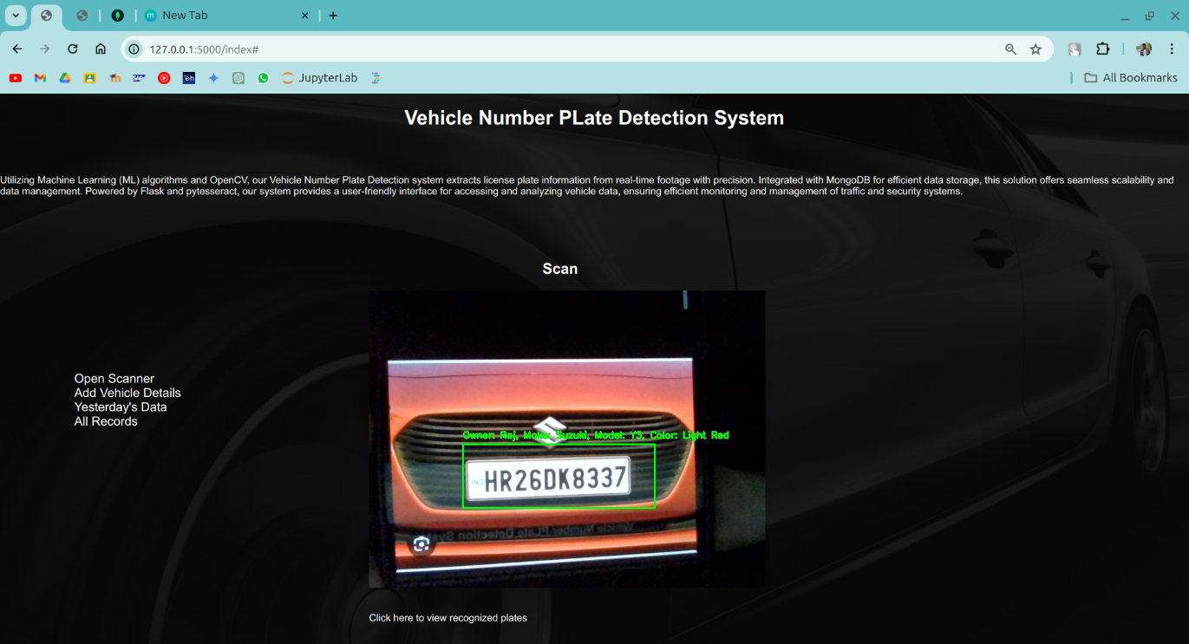

Fig 1.5 Scanning Number Plate of a Vehicle

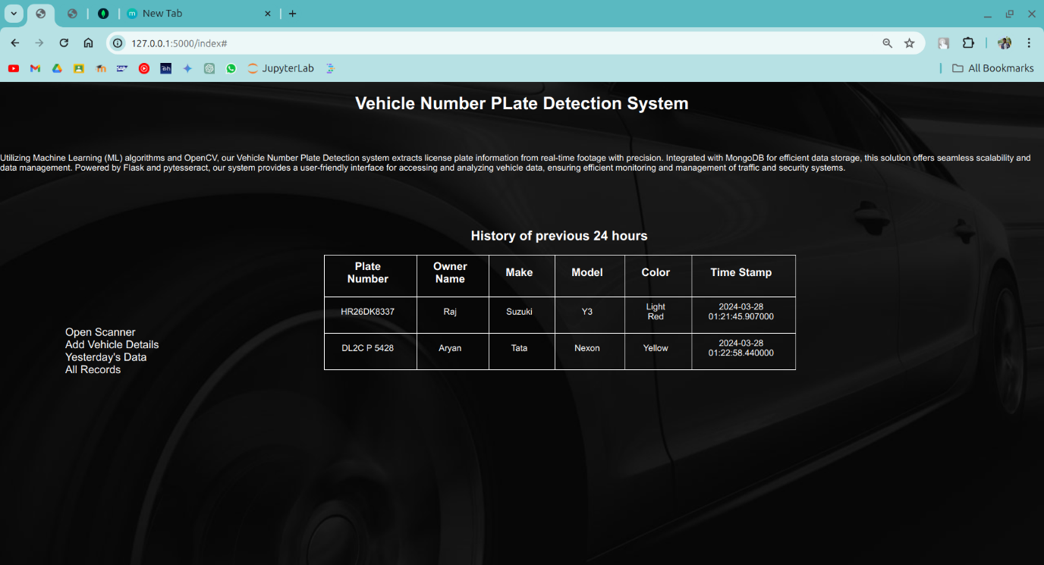

Fig 1.6 Previous 24 hours Data

*School of Computer Engineering, KIIT, BBSR* 16

*Number Plate Recognition System*

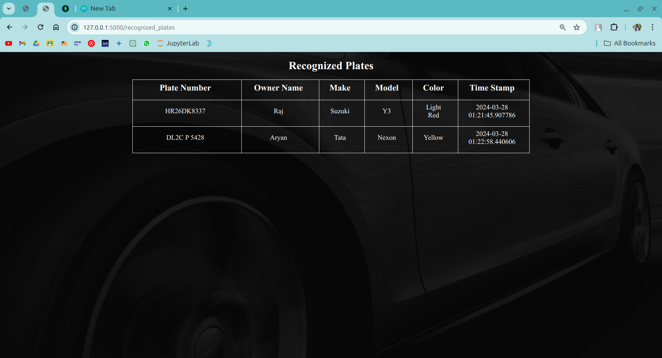

Fig 1.7 Recognized Plates

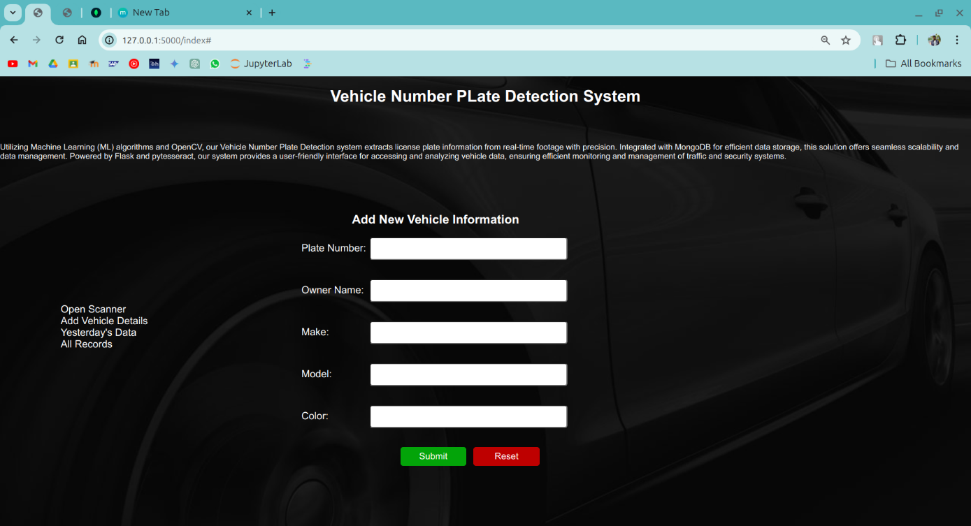

Fig 1.8 Add Vehicle Details

*School of Computer Engineering, KIIT, BBSR* 17

*Number Plate Recognition System*

Chapter 5

Standards Adopted

5.1 Design Standards

5.1.1 IEEE Standards

* IEEE 802 Series: Ensures compatibility with network protocols for data transmission and communication within the number plate detection system, facilitating effective communication with external systems or databases if required.
* IEEE 610.12: Utilized for comprehensive documentation of software engineering processes throughout the development lifecycle of the number plate detection system, ensuring clear and structured documentation for future reference and maintenance.
* IEEE 1016: Employed for detailed documentation of the architecture, components, interfaces, and interactions of the number plate detection system, facilitating easier understanding, maintenance, and potential future enhancements.

5.1.2 ISO Standards

* ISO 9001: Ensures consistent delivery of high-quality software products, including rigorous testing and validation procedures for the number plate detection system, meeting quality standards and customer expectations.
* ISO 14001: Incorporates environmental management principles to minimize the environmental impact of software development processes, such as energy consumption in systems hosting the system, promoting responsible and sustainable development practices.

5.1.3 UML Diagram

Use Case Diagrams: Utilized to represent user interactions and system functionalities in the number plate detection system. This diagram illustrates the various actions users can take and the system's response to those actions, providing a high-level overview of the system's functionality.

*School of Computer Engineering, KIIT, BBSR* 18

*Number Plate Recognition System*

5.1.4 Database Design Standards

* Normalization or Scaling: Reduces redundancy and improves data integrity by organizing data into well-structured tables, minimizing data duplication, and ensuring efficient storage and retrieval of datasets for number plate detection.
* Naming Conventions: Enhances readability and maintainability by following consistent naming conventions for tables, columns, and constraints, facilitating understanding of the database schema used in the number plate detection system.
* ACID Properties: Maintains data consistency and transactional integrity during database operations for number plate detection datasets, ensuring reliable execution of database transactions and preventing data corruption or loss.

5.2 Coding Standards

* Adopt consistent naming conventions for variables and functions.
* Organize code into modular components with clear responsibilities.
* Document code thoroughly with inline comments and high-level descriptions.
* Implement error handling to gracefully manage exceptions and failures.
* Follow a consistent code formatting style and adhere to best practices for readability and maintainability

5.3 Testing Standards

* ISO/IEC/IEEE 29119: Offers a methodical framework for software testing, guiding comprehensive testing procedures from inception to deployment. Ensures rigorous testing practices for a dependable number plate detection system.
* IEEE 829: Specifies the structure of test documentation, including test plans, cases, and reports. Ensures coherence and thoroughness in testing processes, validating all functionalities of the number plate detection system effectively.

*School of Computer Engineering, KIIT, BBSR* 19

*Number Plate Recognition System*

Chapter 6

Conclusion

6.1 Conclusion

The development of the number plate detection system utilizing Python, OpenCV, a website for data presentation, and MongoDB as the database marks a significant advancement in traffic management and law enforcement technology. Through the integration of these cutting-edge technologies, the system offers a robust solution for automatic number plate recognition, enabling efficient identification and tracking of vehicles.

Python and OpenCV provide powerful tools for image processing and computer vision, allowing for accurate detection and extraction of number plate regions from vehicle images. Leveraging these libraries, the system can preprocess images, apply contour tracing, and perform Optical Character Recognition (OCR) to extract alphanumeric characters from number plates with high precision.

The integration of a website using HTML, CSS, and backend frameworks facilitates the visualization and presentation of the detected number plate data to users. This user-friendly interface enhances accessibility and usability, enabling stakeholders to easily access and analyze vehicle information captured by the system in real-time. Moreover, MongoDB serves as a reliable and scalable database solution, effectively storing and managing the vast amount of vehicle data collected by the system.

In essence, the combination of Python, OpenCV, website development technologies, and MongoDB in the number plate detection system exemplifies the synergy between software engineering, computer vision, and database management. This innovative solution not only enhances traffic management and law enforcement efforts but also showcases the potential of technology to address real-world challenges effectively.

*School of Computer Engineering, KIIT, BBSR* 20

*Number Plate Recognition System*

6.2 Future Scope

1. Improved Accuracy: Enhance detection accuracy using advanced machine learning and deep learning methods.
2. Real-time Updates: Integrate IoT devices for instant vehicle movement updates and parking status monitoring.
3. Cloud Integration: Utilize cloud solutions for scalable data storage and processing, ensuring system performance.
4. Multi-Language Support: Extend recognition capabilities to accommodate different languages on number plates.
5. Mobile Application: Develop a mobile app for convenient access to vehicle information and alerts on-the-go.

*School of Computer Engineering, KIIT, BBSR* 21

*Number Plate Recognition System*

***References***

[1] A New Approach for Vehicle Number Plate Detection, Sarthak Babbar; Saommya Kesarwani ; Navroz Dewan ; Kartik Shangle ; Sanjeev Patel, 2018

Eleventh International Conference on Contemporary Computing (IC3)

[2] <https://pyimagesearch.com/2020/09/21/opencv-automatic-license-number-plate-recognition-anpr-with-python/>

[3] <https://github.com/vjgpt/Vehicle-Number-Plate-Reading/tree/master>

[4] <https://www.geeksforgeeks.org/license-plate-recognition-with-opencv-and-tesseract-ocr/>

[5] <https://flask.palletsprojects.com/en/3.0.x/tutorial/>

[6] <https://www.kaggle.com/code/sarthakvajpayee/license-plate-recognition-using-cnn>

[7] Chaudhary, A., Arora, C., & Sharma, D. (2018). A Review on

Automatic Number Plate Recognition System. International Journal of

Computer Applications, 181(37), 1-5.

[8] Singh, S., & Kaur, A. (2019). A Review Paper on Automatic Number

Plate Recognition System. International Journal of Computer Sciences

andEngineering,7(6),99-103.

[9] Ahmed, I., Ghulam, Y., & Wajahat, A. (2021). A Review on Number

Plate Recognition Systems Using Deep Learning. IEEE Access, 9,

35198-35216.

[10] Rashid, M., Nawaz, S., & Muhammad, F. (2019). A

Comprehensive Review on Automatic Number Plate Recognition

Systems. International Journal of Advanced Computer Science and

Applications, 10(9), 82-86.

*School of Computer Engineering, KIIT, BBSR* 22

*Number Plate Recognition System*

[12] <https://www.vigilantsolutions.com/products/license-plate-recognition/>

[13] <https://www.q-free.com/solutions/automatic-license-plate-recognition-anpr/>

[14] <https://www.openalpr.com/>

[15] <https://clearview.ai/>

[16] <https://www.mobile-anpr.com/>

[17] <https://github.com/tesseract-ocr/tesseract>

[18] Jain, M., Jain, A., & Tiwari, M. (2018). A Review on Automatic Number Plate Recognition System. International Journal of Scientific & Technology Research.

[19] Khattak, H., Anwar, W., & Khattak, S. (2020). A Review on Automatic Number Plate Recognition System Using Various Techniques. International Journal of Advanced Computer Science and Applications, 11(1), 19-25

[20] <https://github.com/sergiomsilva/alpr-unconstrained>

*School of Computer Engineering, KIIT, BBSR* 23

*Number Plate Recognition System*

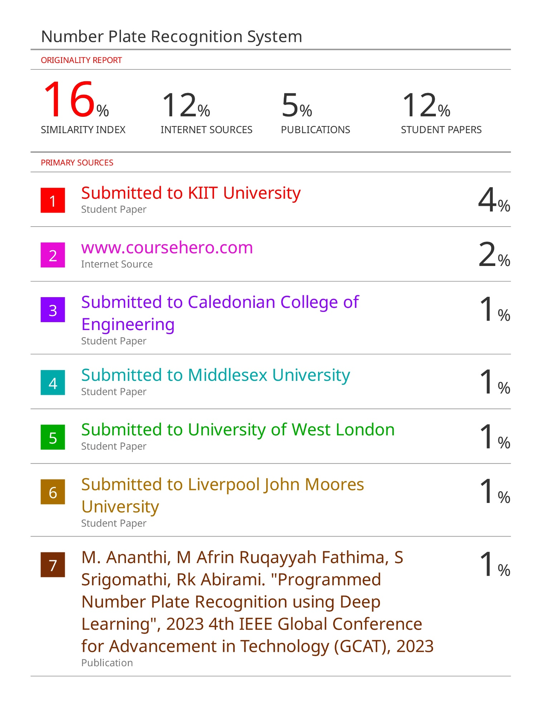

*School of Computer Engineering, KIIT, BBSR* 24

*Number Plate Recognition System*